

**HARRISDALE SENIOR HIGH SCHOOL**

**YEAR 11 SEMESTER 2 2021**

**QUESTION / ANSWER BOOKLET**

PHYSICS

|  |  |  |  |  |  |  |  |
| --- | --- | --- | --- | --- | --- | --- | --- |
|  |  |  |  |  |  |  |  |

**Student number: in figures**

**In Words**

**Time allowed for this paper**

Reading time before commencing work: 10 minutes

Working time: 2 hours 30 minutes

**Materials required/recommended for this paper**

***To be provided by the supervisor***

* This question / answer booklet
* Formulae and Data Booklet

***To be provided by the candidate***

Standard items: pens (blue/black preferred), pencils (including coloured), sharpener, correction fluid/tape, eraser, ruler, highlighters

Special items: up to three calculators, which do not have the capacity to create or store programmes or text, are permitted in this ATAR course examination, drawing templates, drawing compass and a protractor

**Important note to candidates**

No other items may be taken into the examination room. It is your responsibility to ensure that you do not have any unauthorised material. If you have any unauthorised material with you, hand it to the supervisor before reading any further.

**STRUCTURE OF THIS PAPER**

|  |  |  |  |  |  |
| --- | --- | --- | --- | --- | --- |
| Section | Number of questions available | Number of questions to be answered | Suggested working time (minutes) | Marks Available | Percentage of Examination |
| Section One: | 12 | 12 | 50 | 54 | 37 |
| Section Two: | 6 | 6 | 75 | 74 | 51 |
| Section Three: | 1 | 1 | 25 | 17 | 12 |
| Total 145 | 100 |

**INSTRUCTIONS TO CANDIDATES**

1. The rules for the conduct of the Western Australian external examinations are detailed in the Year 12 Information Handbook 2020: Part II Examinations. Sitting this examination implies that you agree to abide by these rules.
2. Write your answers in this Question/Answer booklet preferably using a blue/black pen. Do not use erasable or gel pens.
3. You must be careful to confine your answers to the specific questions asked and to follow any instructions that are specific to a particular question.
4. When calculating or estimating answers, show all your working clearly. Your working should be in sufficient detail to allow your answers to be checked readily and for marks to be awarded for reasoning.

In calculations, give final answers to three significant figures and include appropriate units where applicable.

In estimates, give final answers to a maximum of two significant figures and include appropriate units where applicable.

1. Supplementary pages for planning/continuing your answers to questions are provided at the end of this Question/Answer booklet. If you use these pages to continue an answer, indicate at the original answer where the answer is continued, i.e. give the page number.
2. The Formulae and Data booklet is not to be handed in with your Question/Answer booklet.

**Section One: Short response 37% (54 Marks)**

This section has **twelve (12)** questions. Answer **all** questions. Write your answers in the space

provided. Suggested working time for this section is 50 minutes.

1. **(2 marks)**

Justify whether the following statement is true or false: At the same temperature, atoms of helium move faster, on average, than atoms of xenon.

**Question 2 (3 marks)**

A student is disappointed that he received zero marks in a test question for drawing the diffraction diagram below. In the space below, draw a correct diagram. Note: the frequency for each diagram is different but the gap is the same width.

Diagram 1 Diagram 2

**Question 3** **(6 marks)**

A soft drink company monitors the volume of soft drink added to cans by using a radioisotope. Radiation is directed through the can, near the top. A detector on the other side of the can monitors for radioactivity. When the detector picks up a significant drop in radioactivity as a can passes by, this is an indication the soft drink can was full.

1. State which type of radiation would be suited to this application. Justify your choice.

(3 marks)

1. For this application, state whether it would be better to have a radioisotope with a half life of 2 weeks or 2 years. Justify your choice. (3 marks)

**Question 4 (7 marks)**

The figure shown is a representation of a soundwave in air generated from a single frequency generator, showing compressions (darker regions) and rarefactions (lighter regions) at a particular instant in time. The wave moves from left to right and the speed of sound in air is 342 m s-1.

15.0 cm

Pressure

Distance (m)

(a) Draw a graphical representation of the soundwave on the axes provided above. Determine the scale on the x-axis using the data provided. (2 marks)

(b) Calculate the wavelength and frequency of the wave. (4 marks)

(c) Select the direction of the movement of air molecules during the transmission of energy in this wave from the options below. (1 mark)

A B C D

­

Answer: _____________________

**Question 5 (7 marks)**

Ms Collins is doing a food shop at Coles. Seeing an item on her list, she pushes her 12.5 kg trolley from rest up to 1.70 m s-1.

1. Calculate the work done by Ms Collins on the trolley. (3 marks)

Energy: ___________________ J

1. The trolley was moved 3.20 m during the acceleration. Calculate the average power at which Ms Collins transferred energy to the trolley. If you could not obtain an answer to part (a), use 18.5 J. (4 marks)

Power: ___________________ W

**Question 6** **(4 marks)**

The threshold of pain for human hearing occurs when sound is at an intensity of 10.0 W m-2. A jet engine produces a sound intensity of 562 W m-2 at a distance of 2.00 m from the engine.

1. Describe how sound intensity varies with distance from the source. (1 mark)

1. Calculate how far from a jet engine the intensity of its sound will drop below the threshold of pain. (3 marks)

Distance: ___________________ m

**Question 7** **(4 marks)**

Describe the difference between a longitudinal wave and a transverse wave. Provide an example of each type of wave to support your answer.

**Question 8** **(4 marks)**

Calculate the net force acting on the plane shown in the free body diagram below. Treat up the page as the north direction.

Thrust

3000 N

Drag

2400 N

Cross wind

800 N

Net Force: ___________________ N

Direction: ______________________

**Question 9** **(3 marks)**

In this question, take downwards velocity and displacement as negative.

(a) Which of the velocity-time graphs shown below best represent an object released from a position 10 meters above the ground and allowed to fall freely. (1 mark)

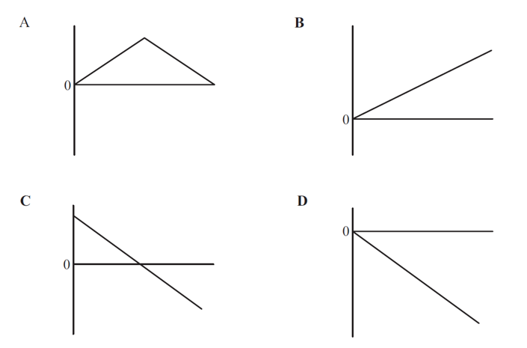 Answer: ____________________

D

C

B

A

(b) On the graph below, sketch the displacement-time graph and the acceleration time graph of the object as it falls. (2 marks)

s (m) a (m s-2)

t (s) t (s)

**Question 10** **(4 marks)**

A closed pipe is 1.35 m long and 15.0 cm in diameter.

1. Calculate the wavelength of the fundamental wave that would resonate in the pipe.

(2 marks)

Wavelength: ___________________ m

1. Calculate the length of an open pipe that could produce the same fundamental frequency as the closed pipe as in part (a). (2 marks)

Length: ___________________ m

**Question 11 (4 marks)**

A world class sprinter can burst out of the starting blocks to his top speed of 11.5 m s-1 in the first 15.0 m of the race. Calculate the average acceleration of the sprinter and the time it takes to reach that speed.

**Question 12** **(6 marks)**

A stone of mass *m* is projected upwards with an initial velocity *u* and reaches a maximum height *h.*

(a) When it is at a height of ¾ h from the ground, determine the ratio of Ek to Ep at that point. (2 marks)

1. Determine the height in terms *h* when the speed of the stone is half of the

initial velocity *u.*

(4 marks)

**End of Section 1**

**Section Two: Problem-solving 51% (74 Marks)**

This section has **six (6)** questions. You must answer **all** questions. Write your answers in the

space provided. Suggested working time for this section is 75 minutes.

**Question 13 (10 marks)**

Thermodynamic properties of three alcohols are listed in the table below. You have a 100 g sample of each alcohol but are concerned the labels have been mixed up. You have access to a low temperature freezer that can be set between -150 0C and -20 0C, a calorimeter that can measure the amount of heat applied to a sample, and thermometers.

|  |  |  |
| --- | --- | --- |
| **Alcohol** | **Liquid Specific Heat Capacity**  **(J kg-1 K-1)** | **Melting point**  **(0C)** |
| 1-propanol | 2400 | -126 |
| 2-propanol | 2570 | -90 |
| 1-butanol | 2400 | -90 |

1. Describe a method to identify the 1-propanol sample from the other alcohols based on their thermodynamic properties. (2 marks)

1. Describe a method to identify the 2-propanol from the other alcohols based on their thermodynamic properties. In your description, include the useful states of matter, measurements and/or calculations performed. (4 marks)

1. Calculate the mass of water at 20.0 0C required to raise the temperature of the 100 g sample of 1-butanol from -50.0 0C to -15.0 0C. (4 marks)

Mass: ___________________ kg

**Question 14** **(10 marks)**

The triple-alpha process is a set of nuclear reactions that occur in the cores of stars in which three alpha particles are transformed into carbon. The first reaction is the fusion of two alpha particles to form Be-8. This reaction requires an input of 0.0918 MeV, taken from the star’s core. A third alpha particle fuses with Be-8 to form C-12. This second reaction releases 7.37 MeV.

1. State the composition of an alpha particle. (1 mark)

1. Write the first reaction of the triple-alpha process. (2 marks)

1. Calculate the mass, in kilograms, gained by the fusion of the first two alpha particles.

(3 marks)

Mass: ___________________ kg

1. Write the second reaction of the triple-alpha process. (2 marks)
2. Calculate the net energy released by a completed triple-alpha process. (2 marks)

Energy: ___________________ MeV

**Question 15 (10 Marks)**

Consider the two circuits below, which have identical power sources and globes. Circuit A has three globes connected in series while circuit B has three globes connected in parallel.

$$V_{T}$$

$$V_{T}$$

Circuit B

Circuit A

1. Redraw circuit A below with an ammeter and voltmeter included. The ammeter and voltmeter need to allow for the measurement of the current and voltage of a single globe.

(2 marks)

1. Determine the equivalent resistance of the circuit in terms of the resistance of a single globe, R. Show clear working.

* + 1. For Circuit A (2 marks)
    2. For Circuit B (2 marks)

1. By determining an expression for the power dissipated by a globe from each circuit in terms of the resistance of a single globe (R) and the voltage of the emf source (VT). You can assume the light bulbs are of the same resistance and are Ohmic. (4 marks)

Circuit: ___________________

**Question 16 (16 marks)**

The reconstruction of a traffic accident based on the testimonies of eyewitnesses and evidence found on the road is shown below in three stages; before the collision, at the moment of impact, and after the collision. The skid marks seen in the diagrams reveal the distance over which Car 1 was braking hard. Car 1 has a maximum braking force of 16800 N. You may assume that Car 1 only ever applied the full force of its brakes.

Car 1

Car 2

Before collision

$$m=1200 kg v=75 km h^{-1}$$

$$m=950 kg v=0 km h^{-1}$$

13.0 m

Car 1

Car 2

Moment of impact

13.0 m

1.50 m

5.00 m

Car 1

Car 2

After collision

1. Explain whether a car crash is an example of an elastic or inelastic collision. (3 marks)

**Question 16 continued**

1. Show that the velocity at which Car 1 collided with Car 2 is approximately 8 m s-1. (4 marks)
2. Calculate the velocity of Car 1 just after the moment of impact. (2 marks)

Velocity: ___________________ m s-1

**Question 16 continued**

1. Hence, calculate the velocity of Car 2 just after the moment of impact. If you could not determine an answer to part (c) you may use 6.50 m s-1. (3 marks)

Velocity: ___________________ m s-1

1. Explain how a car’s crumple zone would have reduced the chance that the driver of Car 1 was significantly injured. (4 marks)

**Question 17 (13 marks)**

A rock is dropped into the middle of a calm lake, creating ripples that are 14.0 cm apart. The wave ripples, as they pass by a cork on the lake’s surface, are shown as a function of time in the graph below.

1. For each time given below, circle the best description of the relative speed of the cork and circle the best description of the direction of the cork’s velocity.
   1. 1.500 s (2 marks)

|  |  |
| --- | --- |
| **Relative** **speed** | **Direction** |
| Large Small Zero | Up Down Left Right Not applicable |

* 1. 1.125 s (2 marks)

|  |  |
| --- | --- |
| **Relative** **speed** | **Direction** |
| Large Small Zero | Up Down Left Right Not applicable |

* 1. 2.500 s (2 marks)

|  |  |
| --- | --- |
| **Relative** **speed** | **Direction** |
| Large Small Zero | Up Down Left Right Not applicable |

**Question 17 continued**

1. Calculate the frequency of the wave. (2 marks)

Frequency: ___________________ Hz

1. Hence, calculate the velocity of the wave. If you could not obtain an answer to part (b), use 0.700 Hz. (2 marks)

Velocity: ___________________ m s-1

1. By referring to the wave equation, describe the changes that would happen to the properties of the wave should the frequency of the ripples of a second rock be twice the magnitude of the first rock. (3 marks)

**Question 18 (15 marks)**

|  |  |
| --- | --- |
| A school experiment is set up to measure the speed of sound in air.  A speaker emitting a frequency of 495 Hz is placed over the top of a container filled with water. The container starts completely full and is drained gradually from a valve at the bottom of the container and the length of air in the tube is recorded when a resonance is heard. The first three resonances are recorded when the length of air in the tube is equal to 0.166 m, 0.520 m and 0.874 m. The speed of sound in air as a function of temperature is known to be:  v(T) = 331 + 0.60T |  |

1. Sketch labelled particle displacement envelopes for the first three harmonics produced.

(3 marks)

(b) Determine the speed of sound in air in the pipe from the experimental results. Ignore any end error in this scenario. (3 marks)

**Question 18** (continued)

(c) Use the value from part (b) to calculate the temperature of the air in the tube. If you could not obtain an answer to part (b), use v = 342 m s-1.(2 marks)

(d) Calculate the location of the next resonance. Assume the tube is sufficiently long and ignore end error. (3 marks)

(e) If a tone of higher frequency were used, explain fully whether the resonances would occur closer together or further apart. (4 marks)

**End of Section 2**

**Section Three: Comprehension 12% (17 Marks)**

This section contains **one** question. Write your answers in the spaces provided.

Suggested working time for this section is 25 minutes.

**Question 19** **(17 Marks)**

**Terminal Velocity**

Introductory Physics classes will often state the acceleration of objects falling near the Earth’s surface as 9.8 m s-2. While this is true in the absence of any air resistance, ignoring air resistance can lead to gross errors between theory and practical results. Objects falling through a fluid, such as Earth’s atmosphere, eventually reach a terminal velocity – the point where no further acceleration occurs.

There are three stages of falling:

1. Acceleration from rest
2. Acceleration while moving
3. Zero acceleration

When an object first starts to fall, from a resting position, there is no air resistance. The initial acceleration of the object will be 9.8 m s-2.

The object will push particles in the air out of the way as it falls. The faster the object falls, the more air it pushes out of the way each second. This is what causes air resistance. At some velocity, the acceleration of the object will be noticeably less than 9.8 m s-2 and will continue to drop as the object picks up speed.

When the object is falling fast enough, there is so much air to push out of the way that the air resistance is just as large as the gravitational force pulling the object down. This causes the acceleration of the object to drop to zero. The object then maintains this falling speed – terminal velocity has been reached.

1. The forces acting on an object falling through the atmosphere determine its acceleration. Draw a free body diagram of the physical forces acting on an object at each of its three stages of falling. Label all forces and keep all free body diagrams to the same scale.

(5 marks)

Acceleration from rest

Zero acceleration

Acceleration while moving

1. The velocity-time graph below shows a bowling ball falling through the atmosphere.

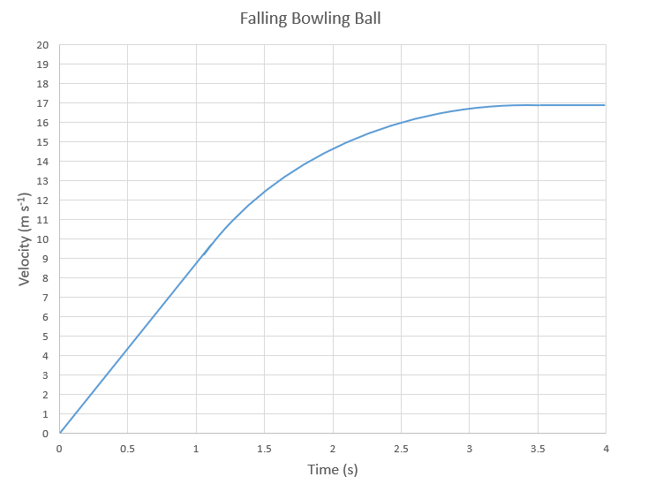

1. Identify and clearly label the region of the graph that shows the first stage of falling as described in the text. (1 mark)
2. Identify and clearly label the region of the graph that shows the third stage of falling as described in the text. (1 mark)
3. Using the graph in part (b), estimate the distance covered by a bowling ball in the first 4.0 s through Earth’s atmosphere. (4 marks)

Distance: ___________________ m

1. On the graph of the bowling ball falling through the atmosphere below, sketch a theoretical velocity-time graph of a golf ball dropped at the same time as the bowling ball, ignoring air resistance. (2 marks)



1. Explain why Newton’s 3rd law of motion is relevant when explaining the cause of air resistance. (4 marks)

**End of Questions**

**Additional working space**

**Additional working space**

**Additional working space**

**Additional working space**

**Additional working space**

**End of Examination**